|  |  |  |  |  |  |
| --- | --- | --- | --- | --- | --- |
| Date | 12-Dec-22 | | | Tester Name | Janette Paus |
| Environment | Penfax - Test 2 | | | Login used | <If different from the Tester> |
| Operating System | Windows | Version: 21H2 | Update Number: | | |
| Software Used | Select Software | Version: 107.0.1418.56 | Update Number: | | |
| Select Software | Version: | Update Number: | | |
| Application Release version | R22.4.1 | | | | |
| Test Case Title | E13.07c | | | | |
| Test Type | Regression | | | | |
| Test Scenario | Add spousal waiver & non-spouse beneficiary for member with spouse (PEPP) | | | | |
| Expected Results | The non-spouse beneficiary can be added with Spousal waiver on file. | | | | |
| Pass/Fail | Pass | | | JIRA# |  |

Search for any PEPP member that has a spouse on profile but no beneficiary listed.

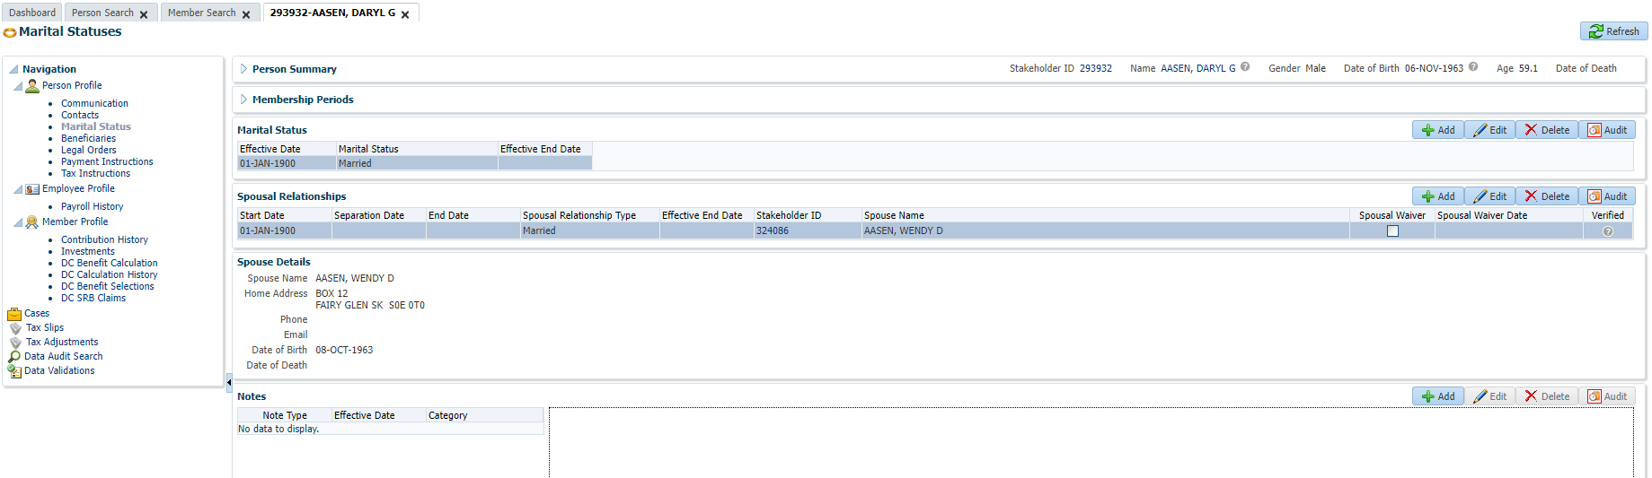

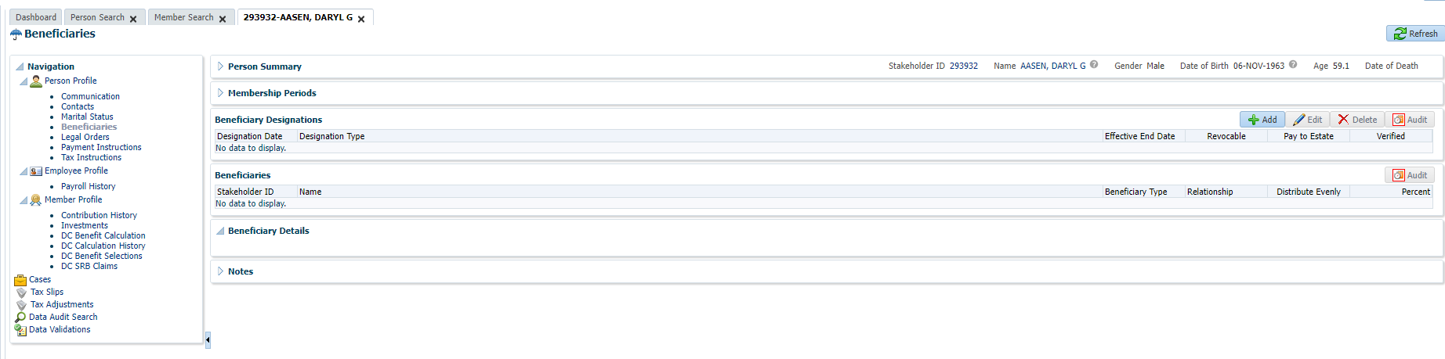

Add Spousal Waiver; go to Member Profile, click Edit and click the box for Spousal Waiver (pre-retirement), then click Save

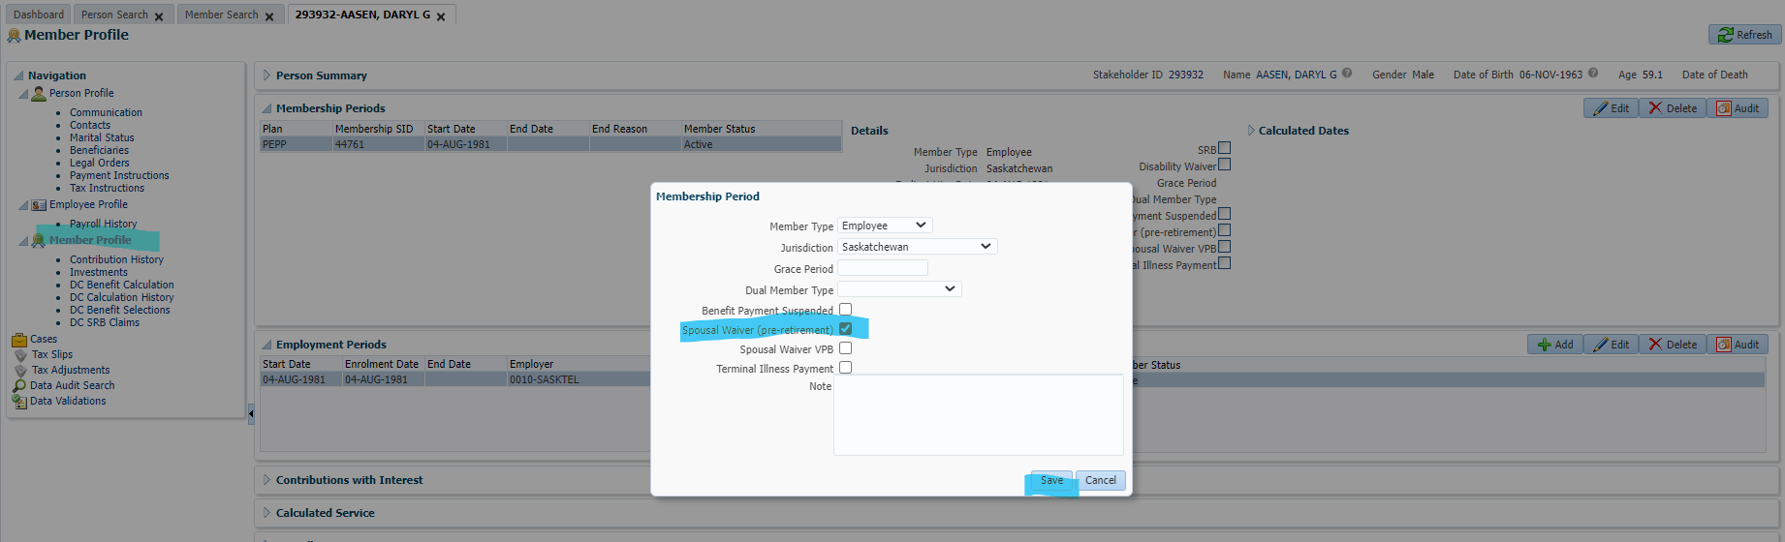

Go to Marital Statuses, click Edit under Spousal Relationships, add the Spousal Waiver Date and click Save

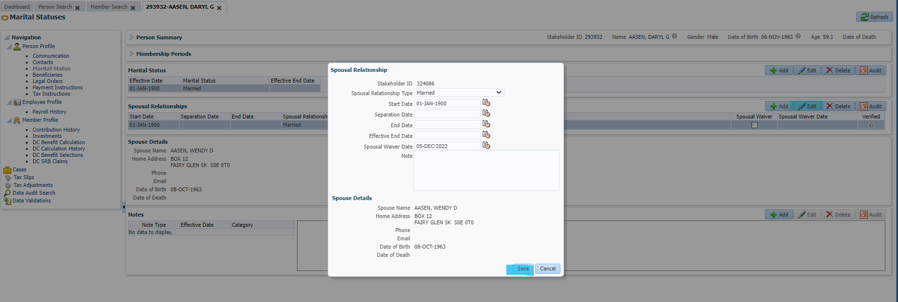

The Spousal Waiver box should be ticked and the Spousal Waiver Date should be populated

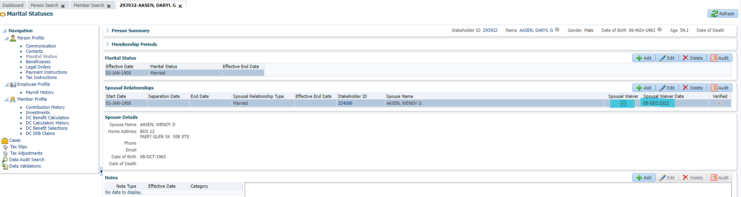

Add non-spouse beneficiary

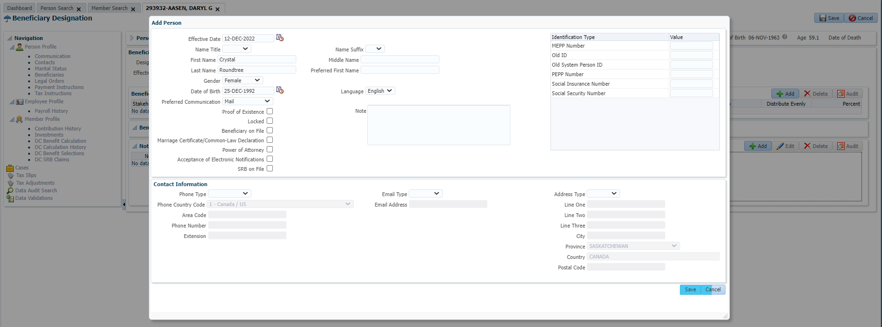

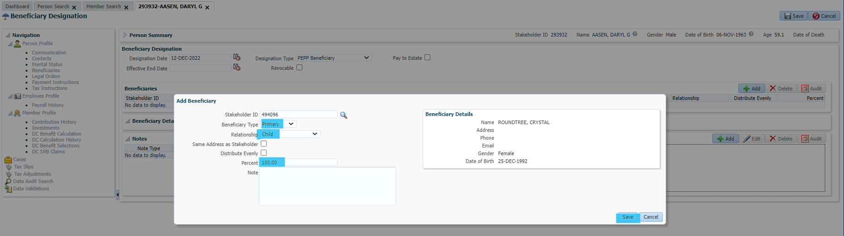

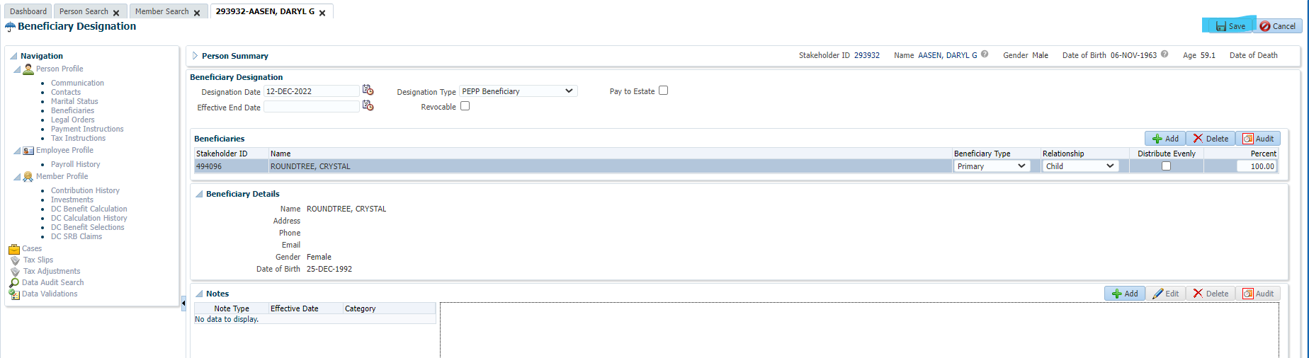

Non-spouse beneficiary successfully added

